

**Open Day visit Report**

**CATHI-Gao and Women’s Field Projects**

**Bamo 17.10.2020**

**Reporters**

Dr Tougiani Abasse

Mr Aminou Ali

Dr Bil Hassan Assanou

Dr Massaoudou Moussa

Dr Hannatou Moussa

Dr Nouri Brah

**Content**

**Context** 3

**Objectives** 3

**Methodology** 4

**First meeting:** 4

**Mission to inform the officials:** 5

**Second meeting:** 5

Day before the ODV: 5

**The ODV day** 5

**Plenary session 1:** 6

**Stand visit:** 6

**Plenary session 2:** 7

**Success stories** 7

**Problems uncountered** 8

**Perspective/recommandation** 8

**Appendix** 9

# **Context**

In the frame work of one of their common objective which is to Strengthen the capacity of all key stakeholders through joint action, CATHI-Gao (*Exploring new ways of agro-ecological intensification of pearl millet-based subsistence farming in Niger*) and Women’ field projects have organized an open day visit (ODV) on 17th of October 2020.

The key stakeholders whom capacity will be strengthen include researchers, technicians, extension workers, students and farmers. The latter are the target group members of the well-structured federation, FUMA-Gaskiya which are at the center of the organized event.

The joint organization of the ODV is to put in action the synergy, which was every year discussed during the COP (community of practice) meeting. Synergy between projects is one of the principles of CCRP (collaborative Crop Research Program). Implementing the synergy between projects allows joint interventions and good management of resources. The two projects have common goal which is to improve the welfare of rural community through diverse agroecological intensification options.

The main objective of the jointly organized ODV is to offer to visitors the reality of the different activities conducted by the two projects around FUMA-Gaskiya. The ODV will be a place of exchange between stakeholders and more than that an occasion to show and sensibilized Policy makers about the work carried out in their entities by the two projects, but also what in this case McKnight foundation is doing to improve the welfare of rural people in Maradi region.

# **Objectives**

The ODV will more specifically:

(i) Present to partners, traditional chiefs and rural communities, results of activities

carried out on-farm by the CATHI-Gao and women's field projects.

(ii) Sensitize participants on the advantages of the activities carried out by the two

projects.

(iii) Build the capacities of facilitators / producers through exchange between all

stakeholders.

# **Methodology**

As stated above, the ODV was jointly organized by CATHI-Gao and Women’s field project. After exchanging on the objectives to be assigned to the ODV and the date it will take place, meetings and fields trip were organized between researchers and technicians to prepare the event:

## **First meeting:**

During the first meeting the following points were discussed and decision were taking.

1. Selection of the village where the ODV will be held. After a rich discussion, the village of Bamo was chosen because of its geographical position, at the center of the intervention zone of the two projects and the motivation of both the village and the local animator.
2. The activities to be presented and how they will be presented, were discussed. In total fourteen (14) agro ecological options (find the list in appendix) were presented, as well as a crushing machine with the demonstration and a kit of animals.
3. After a long analysis the participants invited include

* General Secretary of the Governor of Maradi
* Official (Chairman of Madarounfa local government who was in charge of opening the ODV, the Traditional Chef of Djirataoua and the deputy Mayor of Djirataoua Municipality, the regional director of agriculture and the regional Coordinator of initiative i3N strategy (The Nigerien Nourish the Nigerien).
* Project team and farmers invited were listed

1. The program of the event (see in appendix)
2. Budget: the budget was assigned to each activity and it has come from the two projects
3. Task distribution: for the success of the organization, a task was assigned to animators, technicians, researchers and project PI.

* Technicians: With the local animators they are in charge of identifying the farmers to be participating to the ODV. The farmers were chosen based on their commitment to the project activities and those who conducted trials or obtained results in this season 2020.
* Researchers: In charge of administrative procedure for the funds and vehicle to be allocated for the ODV
* PI: In charge of inviting official
* Pool (Other organizes): In charge of catering, transport etc.

After assigning the task to each team members or group, all tasks were carried out before the due date:

## **Mission to inform the officials:**

Three days before the ODV, a mission conducted by the two PI was carried out to invite the officials. During that mission the Chairman of Madarounfa local government the Traditional Chef and deputy Mayor of Djirataoua Municipality, the regional director of agriculture and the responsible of government initiative 3N were invited. They all accepted the invitation and said were happy that one village in their entities was chosen as a place to conduct the ODV.

## **Second meeting:**

Two days before the ODV a second meeting was organized to assure that all the task distributed were carried out accordingly and to assign other task for the ODV day.

## Day before the ODV:

All projects teams were at Bamo village more precisely the site selected for the ODV to bring, fixe and arrange everything before the due date. Farmers from Bamo village at the chef of village and the local animator Kassoum Maman joined the project team and give their best for the success of the ODV.

## **The ODV day**

The ODV has started at 9h o’clock after the arrival of all official delegation who has promised to attend and to be on time.

The moderator Dr Massaoudou Moussa followed the program accordingly (appendix 1).

# **Plenary session 1:**

The program started with a fatiya or prayer to ask for God guidance, benediction and protection. Thereafter one after another the council deputy and the Chef of Djirataoua village gave their welcome speech which goes in the same line. They first of all welcomed all participant who came from various part of Maradi region, before addressing their gratitude to the two projects in chosen a village under their entities to held the ODV. They are also grateful to all who are contributing to the welfare of farmers. After the two officials, the Director of INRAN welcomed all participants, thanks the officials to honor the event with their presence and said farmers and researchers are there to explain all the activities they are doing. Then come the turn of the two projects PI who, thanks all participants for accepting the invitation before given the main objective of the ODV which is to offer to visitors the reality of the different activities conducted by the two projects around FUMA-Gaskiya. They also gave the objective approach and activities of their project.

The opening speech was pronounced by the state general secretary. He thanks the two projects of organizing the greet event. The main objective of the two projects which is contribute to improve food security and nutrition to small holders’ farmers is in line with the Niger government program initiative 3N. After giving the objectives of the ODV which according to him are to (1) present to officials, partners and rural communities the results of their activities, (2) sensitize their partners on activities conducted and (3) reinforce the capacities of all stakeholders, he than invite all participant to discover the results obtained by our farmers, for the official to make the journey to be a success. He finished his speech by giving special thanks to McKnight foundation which is financially supporting the two projects.

The list of participants is presented in the appendix 2.

# **Stand visit:**

After the opening speech, time was giving to the participants to discover the rich products from AEI options tested this year 2020 as well as the crushing machine and a kit of animals brought for that purpose. The procedure was that each farmer stands before its product and the officials, researchers and other farmers followed stand by stand where each farmer will explain his product and answer questions. At each stand the farmer will be help if necessary, by his local animator and his technician. All the AEI options were presented before presenting with demonstration the crushing machine and then the animal kit (Appendix 3).

Officials, Researchers and all farmers followed stand by stand until the end with great interest. The presentations drown many questions and comments which were answered by farmers and projects team. The presentation with demonstration of the crushing has lighten the event. The processing of mixed crop residue with tree pods and salt in powder of feed animal, drowned the interest of many participants. The target of this exercise was to show how one could economize the small quantity of resources for feeding animal during dry season; especially in year of forage defiency.

The list of AEI options results presented are in the appendix 3. Some testimonies were collected from the participants and summarized in the appendix 4.

# **Plenary session 2:**

After the stand visit it was time for presentations:

* Local animators: five local animators selected following the climate gradient (south, center, north and Est) and taking into account the age and sex gave their presentation. Each animator presented the number of farmers enrolled in the activities, he is conducting, more precisely the AEI options tested this year and his impression about his work.
* Technicians: Seven technicians in charge of supervising animators. Each of them presented his task and highlighted the number of unions of Farmers, he is monitoring .
* Researchers: Three researchers presented respectively on AEI options results, assisted natural regeneration (ANR) and animal activities Habanaye.

# **Success stories**

* All the officials invited honored the even with their attendance and expressed total satisfaction on the diverse results, products displayed by Farmers
* Many women came even those who were not invited throughout the surrounding Bamo village
* Beyond, the official number allocated to each village for ODV participation, the chief of Mayki village from his own initiative sponsored six other women to attend the event.
* Question asked and comments by the official during the stand visit testified their interest giving to the even
* The frame work or the structure of presentation from farmers to local animators to technicians and then to researchers has highlighted the structure of Farmers Research Network (FRN)
* The joint organization of the ODV has shown the real synergy existing between the two projects which is one of the CCRP principles.
* It is a first even showing synergy in action between two CCRP projects

# **Problems uncountered**

* **Budget:** In the budget of INRAN, there is no line for exchange visit which make INRAN team not able to bring other scientists to the event.
* **COVID-19:** the two projects have wished to invite at least one representative from regional coordination office.

# **Perspective/recommandation**

* **Budget:** TheINRAN CATHI-Gao team wish to be allowed to have a line for exchange event in its budget.
* **ODV:** For the next ODV event (next year) the two projects wish to have among them one of the representatives of coordination office.
* **Synergy:** the two projects wish to organize the next ODV in collaboration with all CCRP projects intervening in Maradi and Niger and even from abroad
* **Products presentation:** The two projects wish during the next ODV not only to present products but also flyers, posters etc. translated in local languages.

To illustrate the events, some pictures have been presented in appendix 5.

# **Appendix**

Appendix 1: **Programm**

|  |  |  |  |
| --- | --- | --- | --- |
| **Sites** | **Structures** | **Nom** | **Temps** |
| **Allocutions** |  |  | **45 minutes** |
| Allocution bien venue maire | Mairie Djirataoua |  | 5 minutes |
| Allocution du chef du canton |  |  | 5 minutes |
| Allocution du Président FUMA | FUMA | Hassan | 5 minutes |
| Allocution du DC | CERRA | Dr Nasser | 5 minutes |
| PI CATHI | INRAN | Dr Abasse | 5 minutes |
| PI Champs de femmes | FUMA | Elhaj Aminou | 5 minutes |
| I3n | I3N | Kanfo | 5 minutes |
| Discour d'ouverture du SGA gouverneur | Gouvernorat |  | 10 minutes |
| **Presentation producteurs** | **Villages** | **Noms** | **30 minutes** |
| RNA pure | Araourayé | Balki Abdou | 2 minutes |
| RNA pure | Dan Banga | Amou Maliki | 2 minutes |
| RNA Associée | Gadé Iya | Tsayaba Mati | 2 minutes |
| Sans RNA associé | Dan tsountsou | Hadjiya Indo Adou | 2 minutes |
| Sans RNA | Dan Farou | Saoudé Nayou | 2 minutes |
| Babban Oga | Dan tsountsou | Hadjiya Saa Abou | 2 minutes |
| Boule cendre et sans boule | Makérawa | Saâdou Nayou | 2 minutes |
| Boule cendre et sans boule | Saé Saboua | Hariya Yahaya | 2 minutes |
| Boule cendre et Boule cendre | Guidan Moussa | Ousmane Salé | 2 minutes |
| Boule cendre et Boule cendre | Mai tsakoni | Dijé Argi | 2 minutes |
| Boule NPK | Araourayé | Rakiya Ibrahim | 2 minutes |
| Boule NPK et Boule NPK | Contagora | Issoufou Issa | 2 minutes |
| Oga et Oga | Indoubba | Abou Ali | 2 minutes |
| Oga et Oga | Bazai | Tchima Oumarou | 2 minutes |
| Oga et sans Oga | Dara Amadou | Tchima Adamou | 2 minutes |
| Oga et sans Oga | Tsamiyar Koura | Minau Bikari | 2 minutes |
| Oga et sans Oga | Guidan Maiganga | Rahamou Idi | 2 minutes |
| Compost et Compost | Dogon Dawa | Salissou Sani | 2 minutes |
| Compost et Compost | Guidan Gougé | Daouda Kané | 2 minutes |
| Compost et sans Compost | Dara Amadou | Abou Moussa | 2 minutes |
| Compost et sans Compost | Mayya uku | Fatima Adamou | 2 minutes |
| Compost et Compost | Guidan Moussa | Jiko Ousmane | 2 minutes |
| Oga et Oga | Contagora | Tsalha Iro | 2 minutes |
| Oga et sans Oga | Mayya uku | Gado Saidou | 2 minutes |
| Oga et sans Oga | Saé Saboua | Aicha Ibrahim | 2 minutes |
| essai mère 1 | Araourayé | Saley Batouré | 2 minutes |
| essai mère 2 | Mayya uku | Abdoullahi Ali | 2 minutes |
| Sans RNA associé | Dan Banga | Elh Ilo Aboubacar | 2 minutes |
| Compost et sans Compost | Batata | Saidou Barka | 2 minutes |
| 16 | 29 | 29 | 2 minutes |
| **Presentation des animateurs** | **Position géographiques** | **Noms** | **30 minutes** |
| Animateur 1 | Sud | Abdoullahi Ali |  |
| Animateur 2 | Centre | Hassan Salha |  |
| Animateur 3 | Nord | Saley Batouré |  |
| Animateur 4 | Est | Saadé Rabiou |  |
| Animateur 5 | Ouest | Harouna Adamou |  |
|  |  | 5 |  |
| **Presentation techniciens** |  | **Noms** | **21 minutes** |
| Technicien 1 |  | Sanoussi Maman | 3 minutes |
| Technicien 2 |  | Mahamadou Ibrahim | 3 minutes |
| Technicien 3 |  | Sami Mari | 3 minutes |
| Technicien 4 |  | Abdoulrachide Sani | 3 minutes |
| Technicien 5 |  | Moutala Neino | 3 minutes |
| Technicien 6 |  | Moutari Salissou | 3 minutes |
| Technicien 7 |  | Maman Sani Ibrahim Moussa | 3 minutes |
|  |  | 7 |  |
| **Presentation des chercheurs** |  | **Noms** | **40 minutes** |
| Chercheur 1 |  | Dr Hannatou | 20 minutes |
| Chercheur 2 |  | Dr Brah | 10 minutes |
| Chercheur 3 |  | Dr Massaoudou | 10 minutes |
| **Mots du Clôture (Gouvernorat)** |  |  |  |

**Appendix 2 : Participants distribution**

|  |  |
| --- | --- |
| **Catégories** | **Nombre** |
| Animateurs | 42 |
| Animatrice | 1 |
| Chauffeurs | 5 |
| Chef action coopérative Maradi | 1 |
| Chef de canton de Djirataoua | 1 |
| Chercheurs | 5 |
| Conseiller FUMA | 1 |
| Directeur FUMA PI Champs de femmes | 1 |
| Garde chef de canton | 1 |
| Garde prefet | 1 |
| Initiative 3N | 1 |
| Maire de Djirataoua | 1 |
| Préfet de Madarounfa | 1 |
| Président FUMA | 1 |
| Producteur | 27 |
| Producteur | 9 |
| Productrice | 61 |
| Secrétaire général FUMA | 1 |
| SGA Gouvernorat | 1 |
| Stagiaires | 3 |
| Techniciens | 7 |
| Trésorier adjoint FUMA | 1 |
| Vice-présidente FUMA | 1 |
| **Total** | **174** |

**List of participants**

|  |  |  |  |  |
| --- | --- | --- | --- | --- |
| N° | Villages | Noms et prénoms | Sexes | Catégories |
| 1 | Warzou | Zoulai Ibrahim | F | Productrice |
| 2 | Araourayé | Balki Abdou | F | Productrice |
| 3 | Dan Banga | Amou Maliki | F | Productrice |
| 4 | Gadé Iya | Tsayaba Mati | F | Productrice |
| 5 | Dan tsountsou | Hadjiya Indo Adou | F | Productrice |
| 6 | Dan Farou | Saoudé Nayou | F | Productrice |
| 7 | Dan tsountsou | Hadjiya Saa Abou | F | Productrice |
| 8 | Makérawa | Saâdou Nayou | F | Productrice |
| 9 | Saé Saboua | Hariya Yahaya | F | Productrice |
| 10 | Guidan Moussa | Ousmane Salé | M | Producteur |
| 11 | Mai tsakoni | Dijé Argi | F | Productrice |
| 12 | Araourayé | Rakiya Ibrahim | F | Productrice |
| 13 | Contagora | Issoufou Issa | M | Producteur |
| 14 | Indoubba | Abou Ali | F | Productrice |
| 15 | Bazai | Tchima Oumarou | F | Productrice |
| 16 | Dara Amadou | Tchima Adamou | F | Productrice |
| 17 | Tsamiyar Koura | Minau Bikari | F | Productrice |
| 18 | Guidan Maiganga | Rahamou Idi | F | Productrice |
| 19 | Dogon Dawa | Salissou Sani | M | Producteur |
| 20 | Guidan Gougé | Daouda Kané | M | Producteur |
| 21 | Dara Amadou | Abou Moussa | M | Producteur |
| 22 | Mayya uku | Fatima Adamou | F | Productrice |
| 23 | Magéni | Salisou Issoufou | M | Producteur |
| 24 | Gadé Iya | Bawalé Ibrahim | M | Producteur |
| 25 | Maiki | Indo Ada | F | Productrice |
| 26 | Guidan Moussa | Jiko Ousmane | F | Productrice |
| 27 | Contagora | Tsalha Iro | M | Producteur |
| 28 | Mayya uku | Gado Saidou | F | Productrice |
| 29 | Garin Maigari | Noura Tsahirou | M | Producteur |
| 30 | Saé Saboua | Aicha Ibrahim | F | Productrice |
| 31 | Bamo | Amara.abou | F | Productrice |
| 32 | Bamo | Aïcha tassiou | F | Productrice |
| 33 | Bamo | Binta. Abou | F | Productrice |
| 34 | Kontagara | Faji Koussoum | F | Productrice |
| 35 | Bamo | Habi saadou | F | Productrice |
| 36 | Bamo | Hajara.issa | F | Productrice |
| 37 | Kontagara | Hajia Saoudé Kassoum | F | Productrice |
| 38 | Bamo | Hariya tassiou | F | Productrice |
| 39 | Kontagara | Haro Issaka | F | Productrice |
| 40 | Bamo | Hassou | F | Productrice |
| 41 | Bamo | Hinda.abdou | F | Productrice |
| 42 | Bamo | Honda abdou | F | Productrice |
| 43 | Bamo | Indo.hallillou | F | Productrice |
| 44 | Kontagara | Indo.issa | F | Productrice |
| 45 | Kontagara | Issaka Maman | F | Productrice |
| 46 | Bamo | Jamilla. Abdou | F | Productrice |
| 47 | Kontagara | Mamou | F | Productrice |
| 48 | Bamo | Nana hadiza | F | Productrice |
| 49 | Bamo | Ou ma. Tassiou | F | Productrice |
| 50 | Kontagara | Oubeda.soule | F | Productrice |
| 51 | Bamo | Rachida shahabou | F | Productrice |
| 52 | Bamo | Rachida. Bassirou | F | Productrice |
| 53 | Kontagara | Rashida Issa | F | Productrice |
| 54 | Bamo | Rashida.illa | F | Productrice |
| 55 | Bamo | Sahara.tassiou | F | Productrice |
| 56 | Bamo | Saiba sani | F | Productrice |
| 57 | Bamo | Salla sani | F | Productrice |
| 58 | Kontagara | Saoudé Issaka | F | Productrice |
| 59 | Bamo | Saratou. Lawali | F | Productrice |
| 60 | Bamo | Shassiya. Iro | F | Productrice |
| 61 | Bamo | Souweba yayouza | F | Productrice |
| 62 | Kontagara | Tibao..mani | F | Productrice |
| 63 | Kontagara | Tsima Mani | F | Productrice |
| 64 | Bamo | Tsima shiitou | F | Productrice |
| 65 | Bamo | Tsima.tassiou | F | Productrice |
| 66 | Kontagara | Zara Mai Gari | F | Productrice |
| 67 | Bamo | Zariya, hamza | F | Productrice |
| 68 | Kontagara | Zouley Issaka | F | Productrice |
| 69 | Bamo | Zouley shaharou | F | Productrice |
| 70 | Kontagara | Zouéra Sani | F | Productrice |
| 71 | Kontagara | Abdou Sani | H | Producteur |
| 72 | Kontagara | Abdul. Malik | H | Producteur |
| 73 | Kontagara | Achirou Adamou | H | Producteur |
| 74 | Kontagara | Ada Oumarou | H | Producteur |
| 75 | Kontagara | Alka Moussa | H | Producteur |
| 76 | Kontagara | Idi Moussa | H | Producteur |
| 77 | Kontagara | Illa Garba | H | Producteur |
| 78 | Kontagara | Illa Issa | H | Producteur |
| 79 | Kontagara | Illia Ali | H | Producteur |
| 80 | Kontagara | Illia Garba | H | Producteur |
| 81 | Kontagara | Illiassou Assouman (wajé) | H | Producteur |
| 82 | Kontagara | Inoussa.garba | H | Producteur |
| 83 | Kontagara | Iro .issoufou | H | Producteur |
| 84 | Kontagara | Issa Iro | H | Producteur |
| 85 | Kontagara | Issa Ousmane | H | Producteur |
| 86 | Kontagara | Issaka Ibrahim | H | Producteur |
| 87 | Kontagara | Issoufou Issa | H | Producteur |
| 88 | Kontagara | Issouhou Mahaman | H | Producteur |
| 89 | Kontagara | Isufu Mamam | H | Producteur |
| 90 | Kontagara | Kassoum Iro | H | Producteur |
| 91 | Kontagara | Laouali Mani | H | Producteur |
| 92 | Kontagara | Lawali Garba | H | Producteur |
| 93 | Kontagara | Malam.garba | H | Producteur |
| 94 | Kontagara | Maman Ibrahim | H | Producteur |
| 95 | Kontagara | Mani Issa | H | Producteur |
| 96 | Kontagara | Mani Naouma | H | Producteur |
| 97 | Kontagara | Moussa Ali | H | Producteur |
| 98 | Angouwal Roumdji | Hamissou Barmo | M | Animateur |
| 99 | Dara Amadou | Harouna Adamou | M | Animateur |
| 100 | Maiki | Hambali mahaman | M | Animateur |
| 101 | Maiki | Saddi Illia | M | Animateur |
| 102 | Maiki | Ali Salissou | M | Animateur |
| 103 | Sae saboua | Almoustapha Abdoulwahabou | M | Animateur |
| 104 | Saé Saboua | Abdoulhamidou Abdoulwahab | M | Animateur |
| 105 | Saé Saboua | Hassan Tsalha | M | Animateur |
| 106 | Batata | Saidou Barka | M | Animateur |
| 107 | Hadamna | Manirou Mamane | M | Animateur |
| 108 | Boussaragui | Moussa Abdou | M | Animateur |
| 109 | Tchaké | Abdoul Azizou Yahaya | M | Animateur |
| 110 | Warzou | Badama Tari | M | Animateur |
| 111 | Mallamwa | Ibbo Abdou | M | Animateur |
| 112 | Serkin Haoussa | Adamou Roro | M | Animateur |
| 113 | Angoual Mata | Abdoulaye Ali | M | Animateur |
| 114 | Araurayé | Saley Batouré | M | Animateur |
| 115 | Dan Tsuntsu | Abdou Jigo | M | Animateur |
| 116 | Dan Banga | Elh Illo Aboubacar | M | Animateur |
| 117 | Dan Tsuntsu | Yaou Jigo | M | Animateur |
| 118 | Dan Banga | Mahabou Innoussa | M | Animateur |
| 119 | Gabi | Rabiou Nassaraoua | M | Animateur |
| 120 | Gabi 2 | Garba Souley | M | Animateur |
| 121 | Gabi 3 | Maliki Maman | M | Animateur |
| 122 | Tchadoua | Issaka Ibrahim | M | Animateur |
| 123 | Tessaoua | Mountaka Abdou | M | Animateur |
| 124 | Tessaoua2 | Saadé Rabiou | F | Animatrice |
| 125 | Dargué | Ibrahim Oumarou | M | Animateur |
| 126 | Souloulou | Abdoul Aziz Mahamadou | M | Animateur |
| 127 | Garin Maigari | Adamou Oumarou | M | Animateur |
| 128 | Garin Maigari | Kabirou Abdou | M | Animateur |
| 129 | Garin Labo | Abdou Tchana | M | Animateur |
| 130 | Garin Labo | Salissou Abdou | M | Animateur |
| 131 | Garin Malam | Tanimoune Salé | M | Animateur |
| 132 | Gadé Iyya | Ousmane Sani | M | Animateur |
| 133 | N’walla Dan Sofoua | Hassane Kokary | M | Animateur |
| 134 | Saé Sofoua | Harouna Idi | M | Animateur |
| 135 | Bamo | Kassoum Iro | M | Animateur |
| 136 | Mayyara | Yacouba Malam Abdou | M | Animateur |
| 137 | Warzou | Idi Abdou | M | Animateur |
| 138 | Dan Malam Yanbougajé | Mahaman Abara | M | Animateur |
| 139 | Serkin Bindiga | Sani Serkin Bindiga | M | Animateur |
| 140 | Serkin Haoussa | Maman Sani Abou | M | Animateur |
| 142 | Maradi | Sanoussi Maman | M | Technicien |
| 143 | Maradi | Mahamadou Ibrahim | M | Technicien |
| 144 | Maradi | Sami Mari | M | Technicien |
| 145 | Maradi | Abdoulrachide Sani | M | Technicien |
| 146 | Maradi | Moutala Neino | M | Technicien |
| 147 | Maradi | Moutari Salissou | M | Technicien |
| 148 | Maradi | Maman Sani Ibrahim Moussa | M | Technicien |
| 149 | Maradi | Mansour | M | Stagaire |
| 150 | Maradi | Saadatou Fodé | M | Stagaire |
| 151 | Maradi |  | M | Stagaire |
| 152 | Maradi | Hassan Salifou | M | Président FUMA |
| 153 | Maradi | Lasseini Adamou | M | Trésorier adjoint FUMA |
| 154 | Maradi | Sani Salha | M | Sécretaire général FUMA |
| 155 | Maradi | Hadjara Oumarou | M | Vice-présidente FUMA |
| 156 | Maradi | Saley Ibrahim | M | Conseiller FUMA |
| 157 | Maradi | Sani Sanoussi | M | SGA Gouvernaurat |
| 158 | Madarounfa | Ousseini Djaho | M | Préfet de Madarounfa |
| 159 | Djirataoua | Chaibou Garba | M | Maire de Djirataoua |
| 160 | Djirataoua | Lawali Oubandawaki | M | Chef de canton de Djirataoua |
| 161 | Maradi | Ousmane Oumarou | M | Chef action coopérative Maradi |
| 162 | Maradi | Kanfo Harouna | M | Initiative 3N |
| 163 | Maradi | Maman Harouna | M | Chaffeur SGA gouverneur |
| 164 | Madarounfa | Kabirou Yahaya | M | Chauffeur Prefet |
| 165 | Djirataoua | Habibou André | M | Chauffeur Maire |
| 166 | Djirataoua | Tahirou Hamissou | M | Chauffeur Chef de canton |
| 167 | Maradi | Bachir Idi | M | Chaffeur DRA |
| 168 | Madarounfa | Mousbahou Abdou | M | Garde prefet |
| 169 | Djirataoua | Harouna Idi | M | Garde chef de canton |
| 170 | Maradi | Hannatou Moussa | M | Chercheur |
| 171 | Maradi | Massaoudou Moussa | M | Chercheur |
| 172 | Maradi | Abass Toudjiani | M | Chercheur PI CATHI |
| 173 | Maradi | Noura Brah | M | Chercheur |
| 174 | Maradi | Nasser Lawali | M | Chercheur Directeur CERA Maradi |
| 175 | Maradi | Ali Maman Aminou | M | Directeur FUMA PI Champs de femmes |

**Appendix 3: List of AEI options presented**

|  |  |
| --- | --- |
| N° | pure Farmer Managed Natural Regeneration |
|  | Farmer Managed Natural Regeneration associated with fertilizer |
|  | Field with fertilizer no associated with Farmer Managed Natural Regeneration |
|  | Field without Farmer Managed Natural Regeneration |
|  | (OGA Liquid) Babban OGA |
|  | Ash Boule and without boule |
|  | Boule cendre et Boule cendre |
|  | Boule NPK et sans boule |
|  | Boule NPK et Boule NPK |
|  | OGA and OGA |
|  | OGA and without OGA |
|  | Compost and Compost |
|  | Compost and without Compost |
|  | Mother Trial 1 |
|  | Mother Trial 2 |
|  | Baby trial on Sorghum Boule |
|  | Mother trial on Sorghum Boule |
|  | Habanayé activity |
|  | Crushing machine |

Appendix 4: **Testimonies**

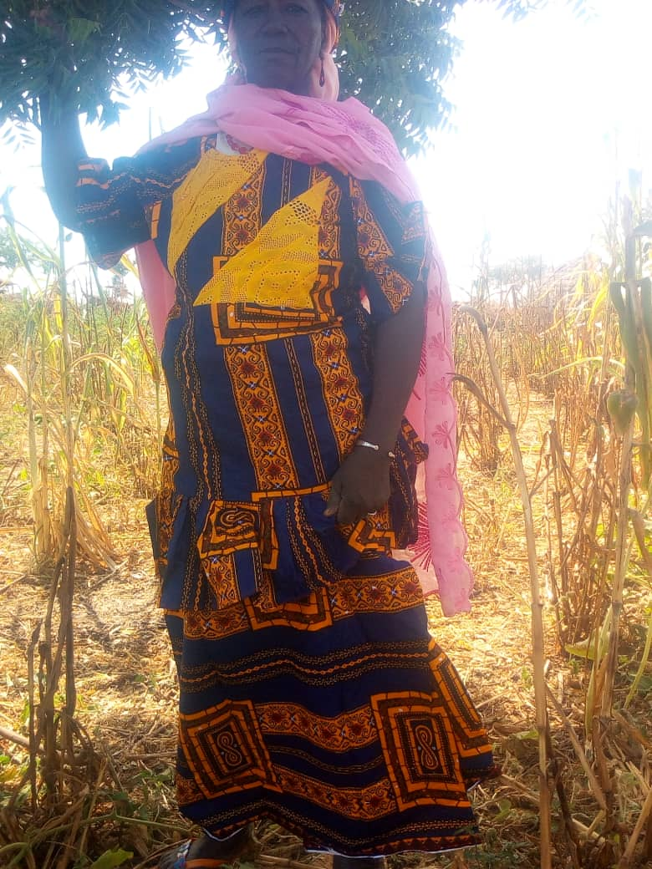**Testimony 1:** I am Haoua Allassan from Arraourayé village, member of Hadin Kai farmer’s organization which is under the union of Haské Koré Duhu. I am always part of volunteers testing many agro ecological options brought to us via FUMA. For this greet event I have brought the results of my trials obtained from CATHI-Gao. The results have really shown the importance of trees in the farm. The results of trials with natural regeneration (ANR) are higher than without ANR even where no fertilizer was use. From now on, we will take care of trees in our field and practice ANR.

Haoua Allassan giving her testimony on CATH-Gao trials (with and without ANR)

**Testimony 2:** I am Hajia Sa’a from Dan Tsuntsu village, member of Alkawali farmer’s organization which is under the union of Haské Koré Duhu. I am one of the first volunteer’s lady to test what we call the Big OGA provide by CATHI-Gao and which is nothing else then human solid waste. I obtained very good results with the application of Big OGA, I have never known it, apart of liquid OGA (fermented human urine) we use as fertilizer and which I have been testing for years and applying on my own field, there is another local source of fertilizer which is cheap and easy to get. I will continue applying it on my farms and asking my fellow women to do so.

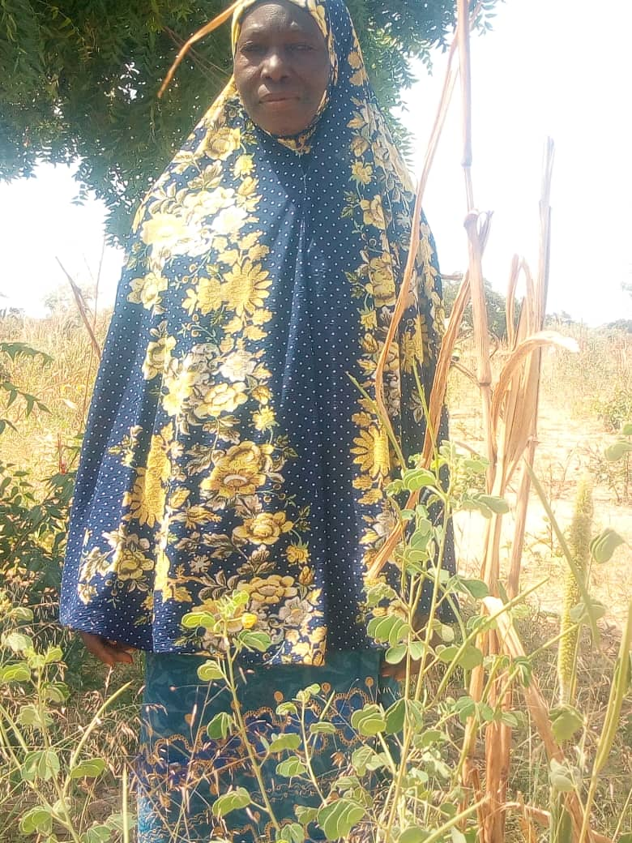

**Hajia Sa’a giving her testimony on OGA Solide (solide human waste)**

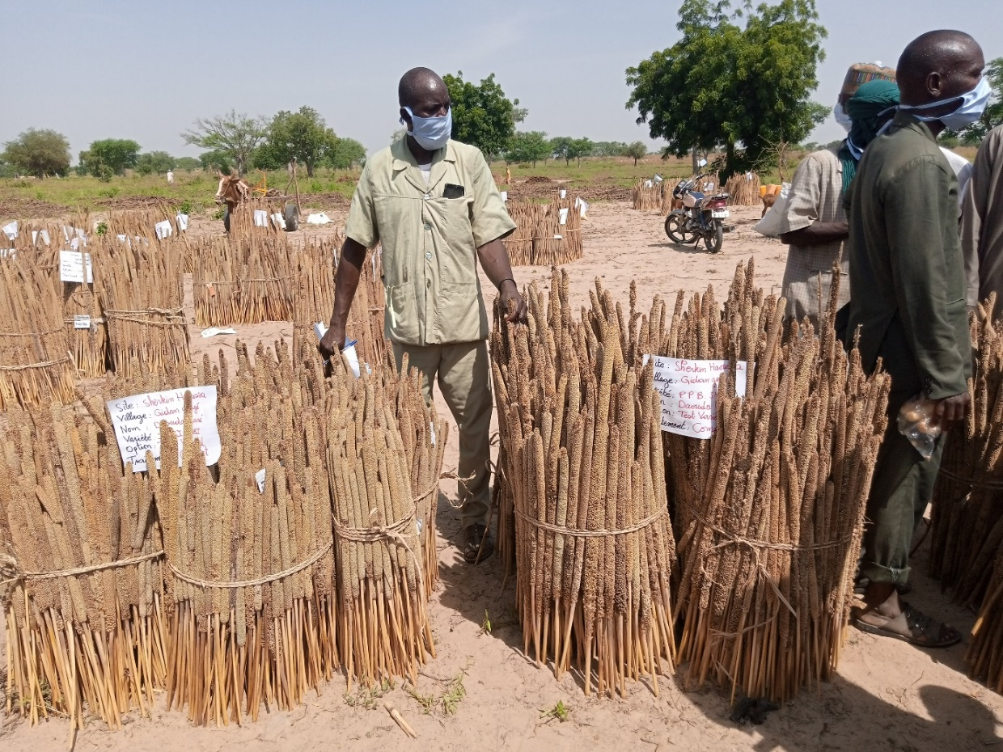Appendix 5: **Pictures**

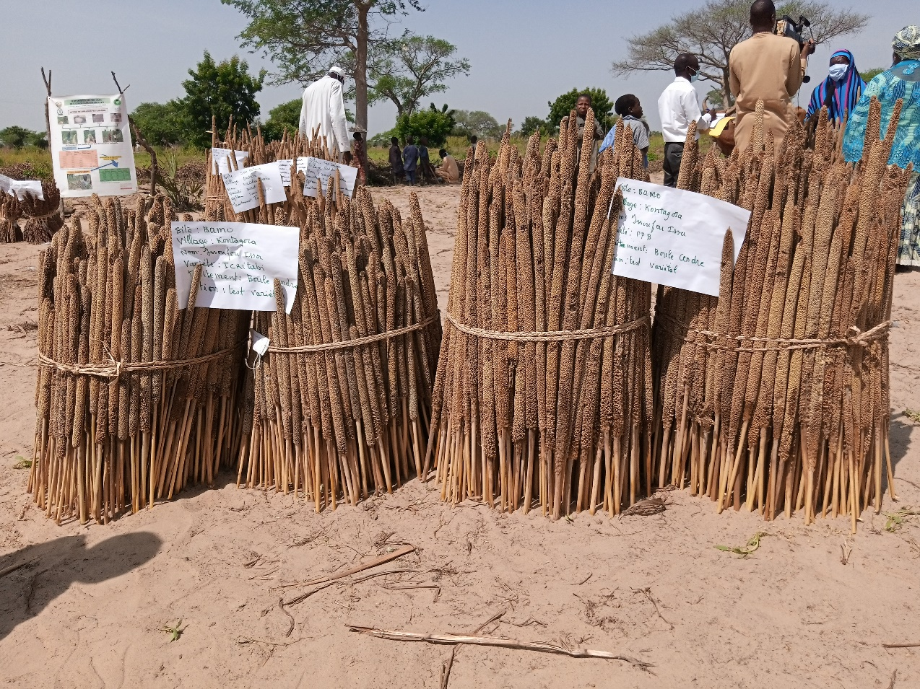

**Ash ball comparative test with ICRIT TABI and PPB Serkin Haoussa**

**Compost comparative trial with two varieties ICRI TABI and PPB serkin Hausa**

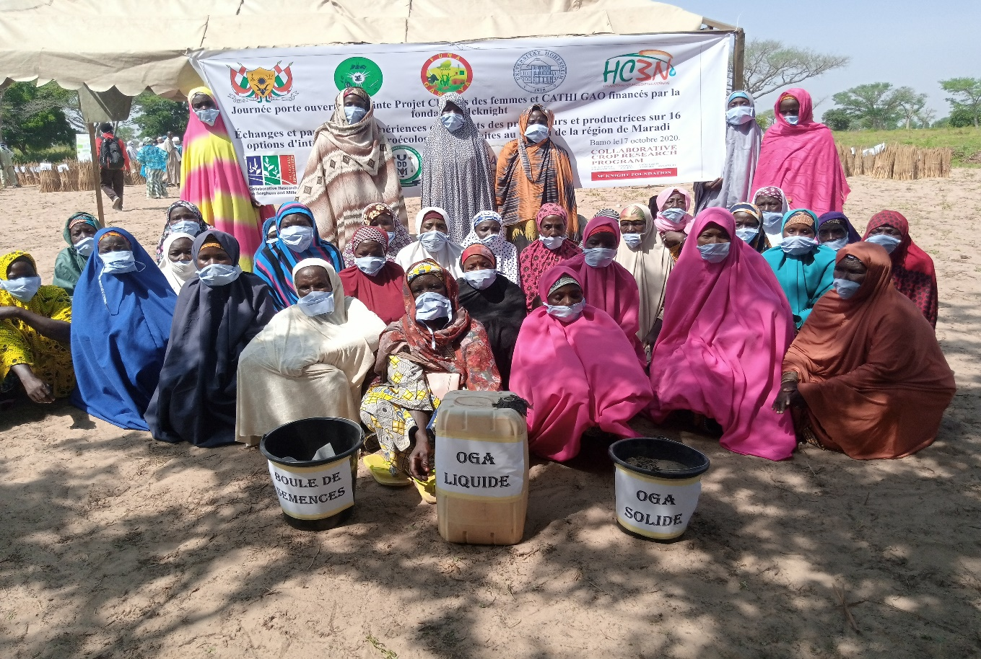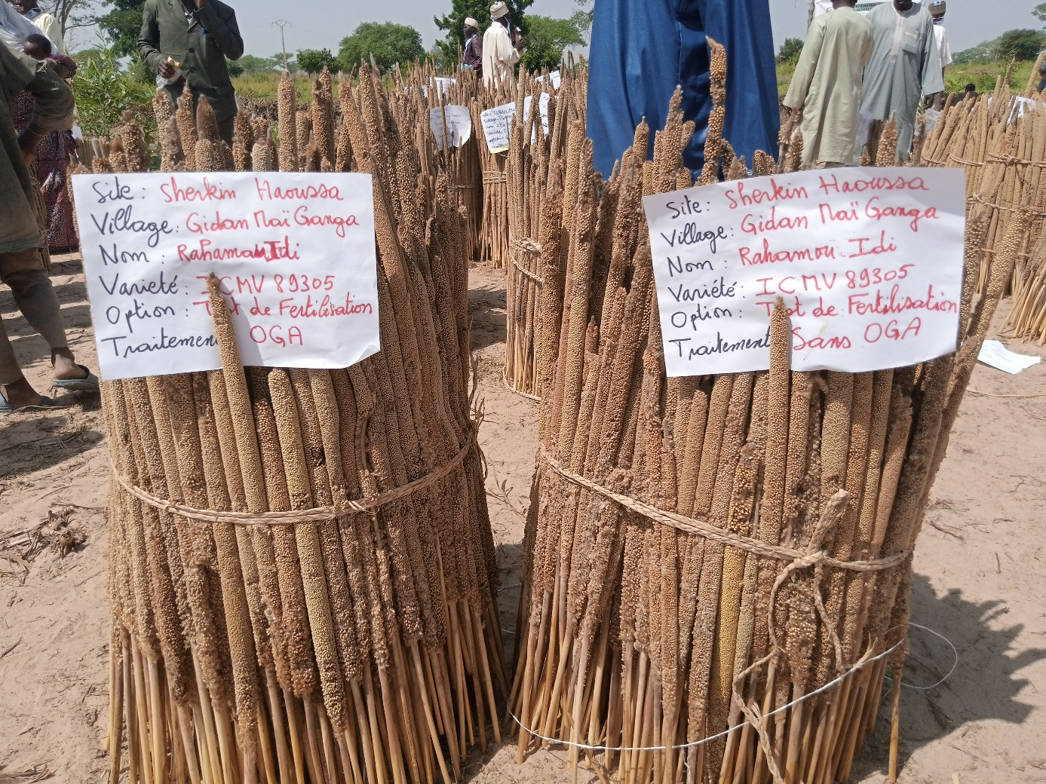

**Solid OGA, Liquid OGA and Ball Women's processing Network**

**OGA and Without OGA trial with the variety ICMV IS 89305**

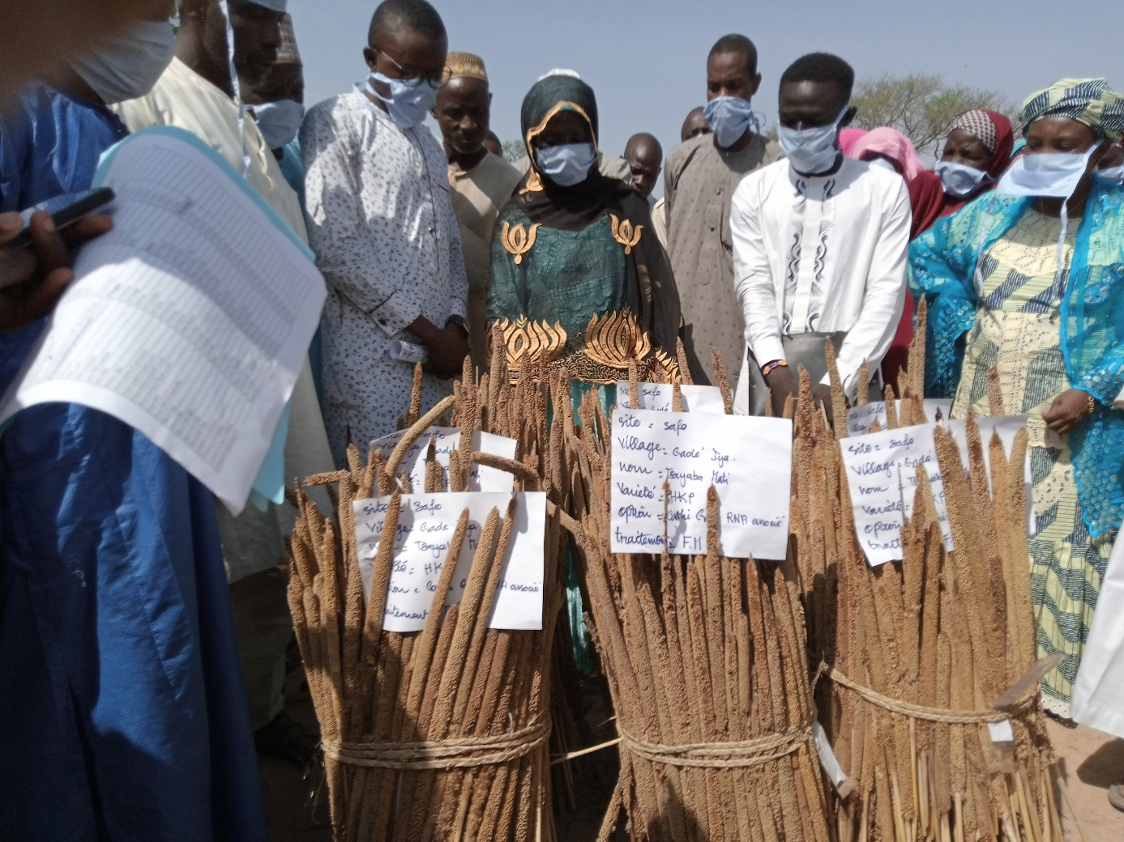

**A woman Farmer from Gadé Iyya discusses the results of her trials with participants**

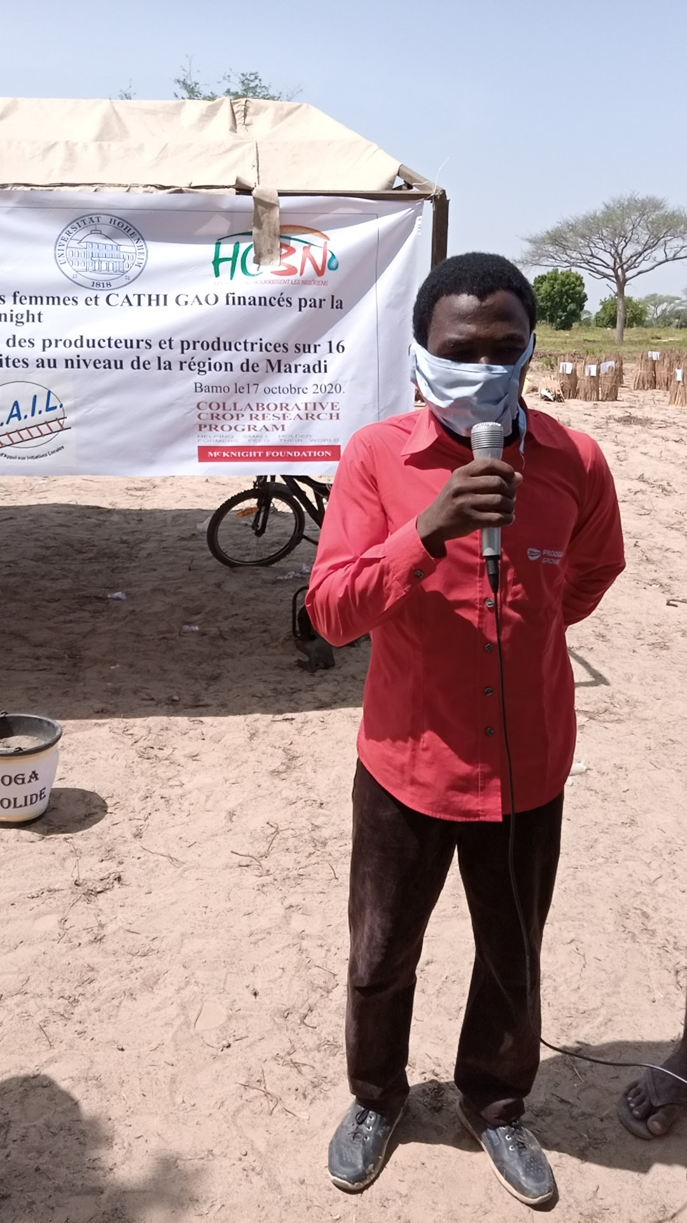

**Exchange of experience by a technician on the framing**

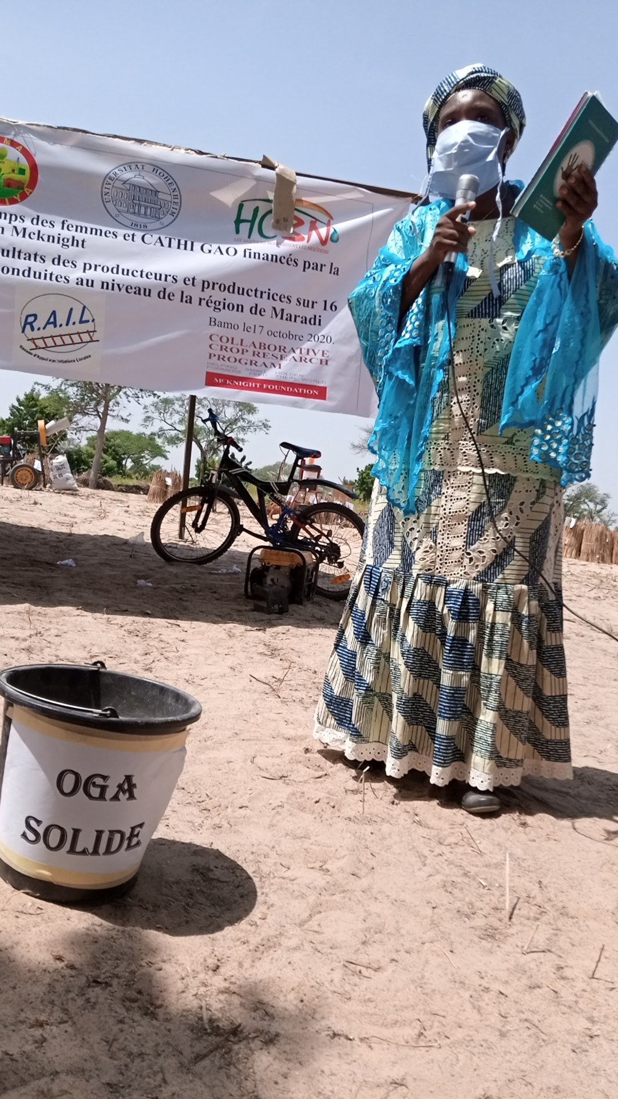

Explanations by Hannatou on the trials conducted with women's field and CATHI-Gao

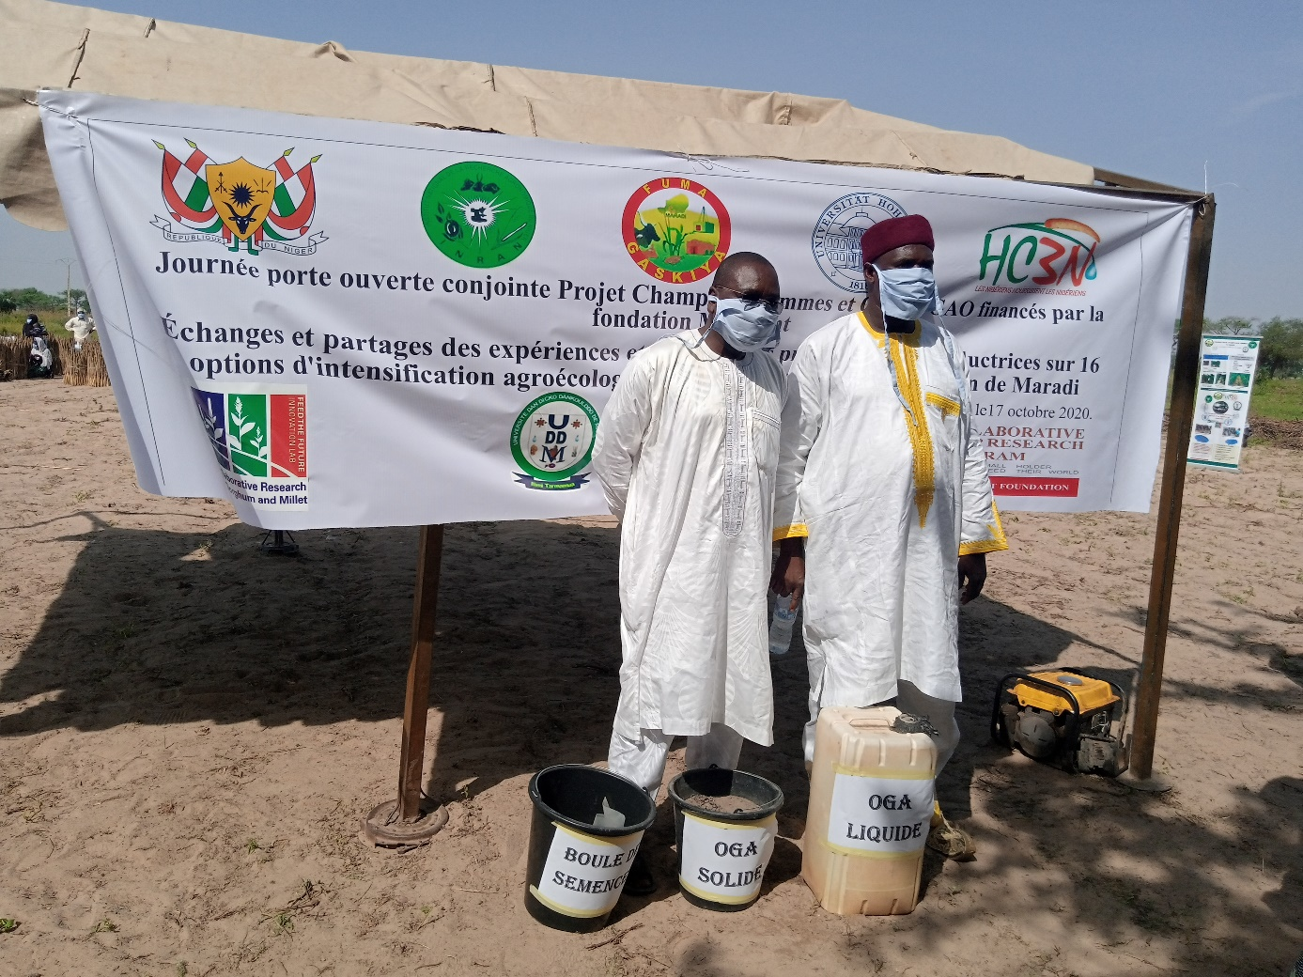

The pride of the two PIs on the joint Open Day Visit a real example of synergy